Exp 6

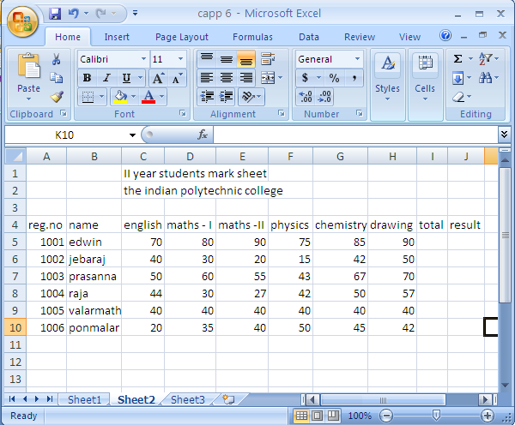

Formula for total: “=SUM(C5:H5)”

Formula for result: “=IF(AND(C8>=40,D8>=40,E8>=40,F8>=40,G8>=40,H8>=40),IF(I8/500\*100>=70,"Distinction", IF(I8/500\*100>=60, "first",IF(I8/500\*100>=50,"second","pass"))),"fail")”

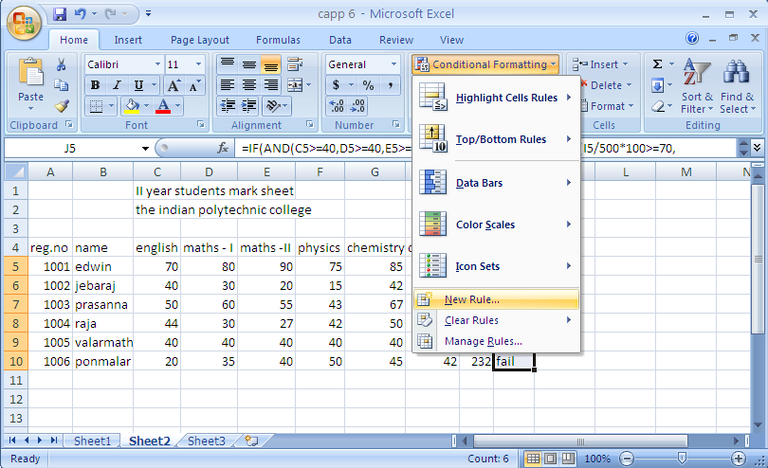

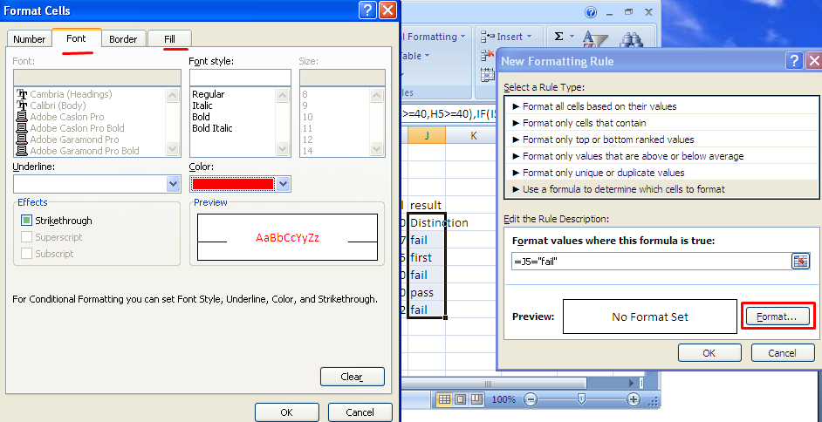

Formula for conditional formatting: “ =J5="fail" “

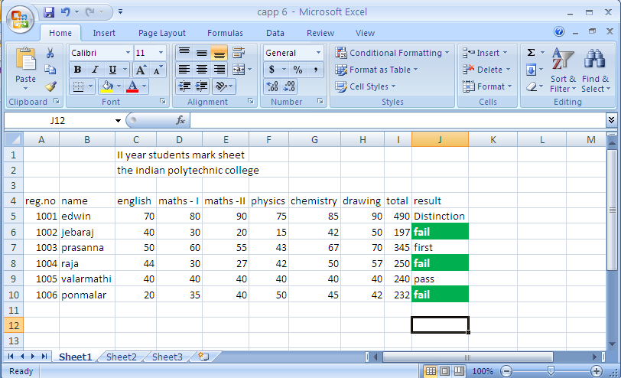

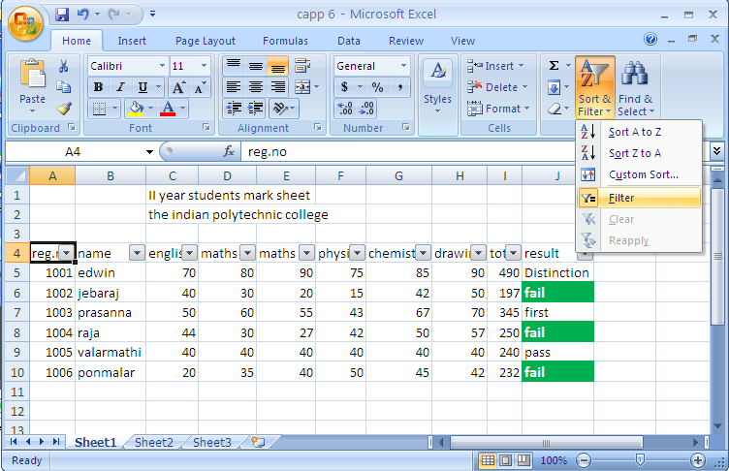

Exp: 7

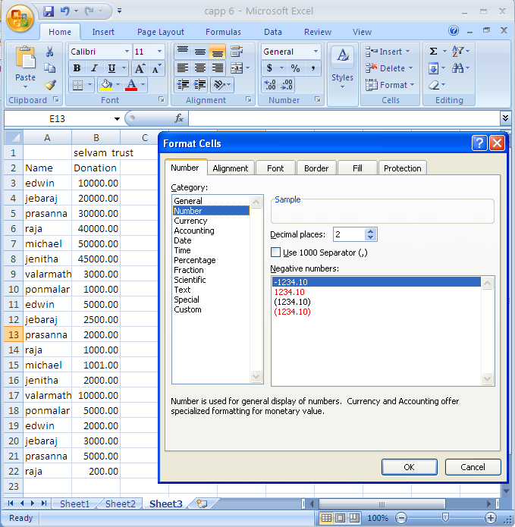

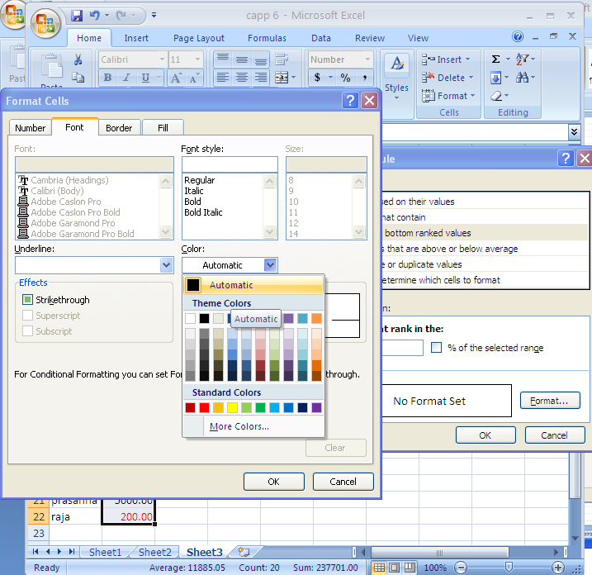

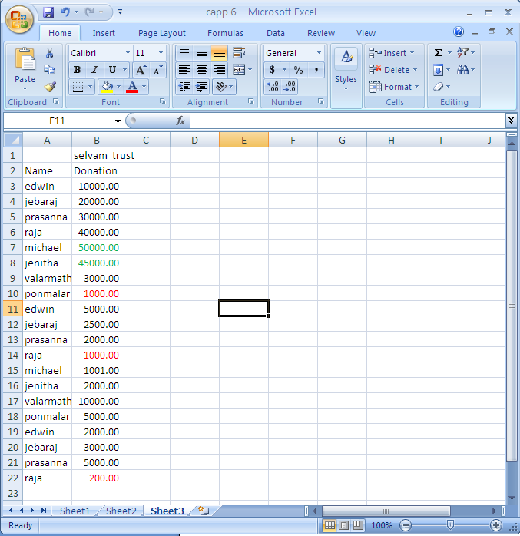

Exp: 8

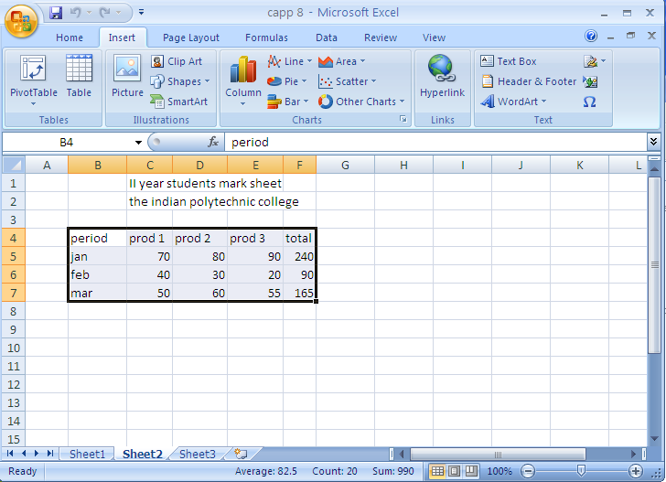

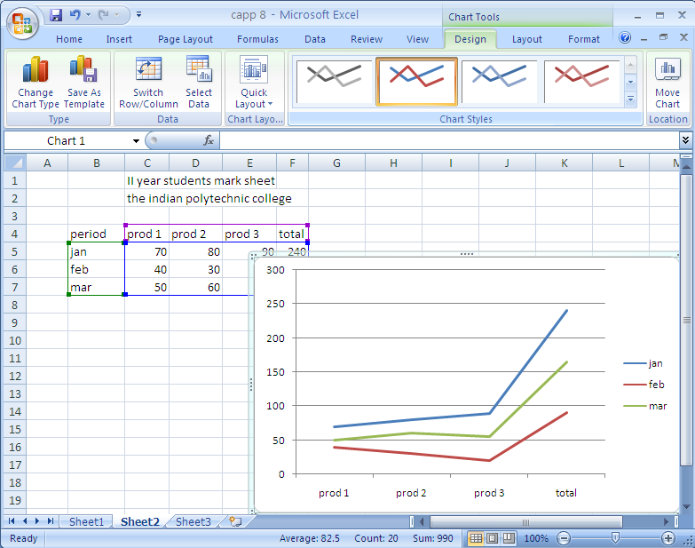

Line chart

Bar chart

